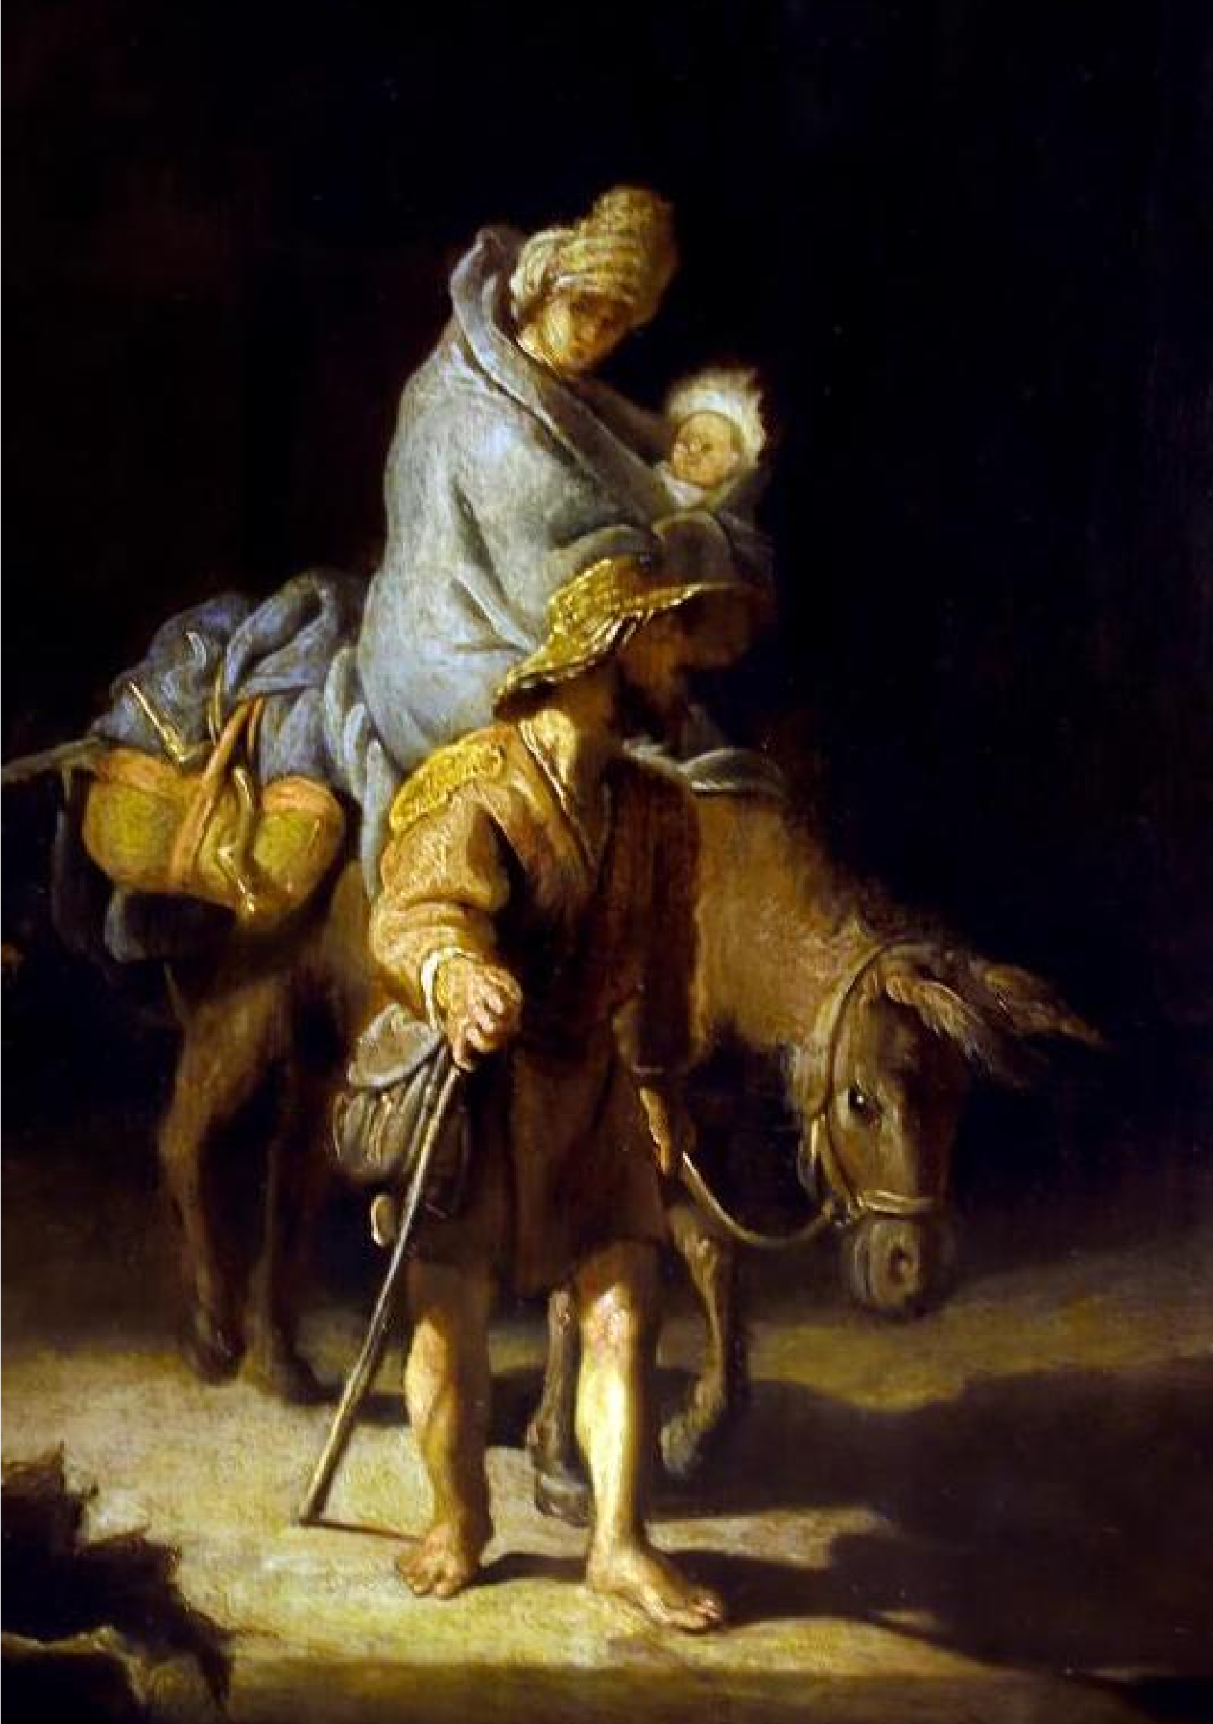

Company Information
THOMAS (Those on the Margins of a Society)
Head Office
St Anne’s House
France Street
Blackburn
BB2 1LX
Tel: 01254 660861
Website: www.thomasonline.org.uk

Registered Charity No: 1114489 Registered Company No: 5577388

At THOMAS, we believe in the power of care and compassion. Every meal served, every life supported, and
every new beginning is a reminder that hope can transform lives. We celebrate the difference we make together and the brighter tomorrows we help create.

288 referrals were made to our residential rehabilitation projects, with 222 assessments and 111 admissions; 300
people accessed our Drop-in Centre for a hot meal, where
11,375 meals were served. 224 individuals engaged with our reach-out project into hostels and the wider community.

Thank you for your support

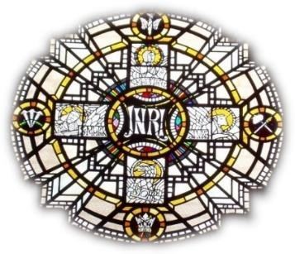
Best wishes for Christmas and throughout 2026

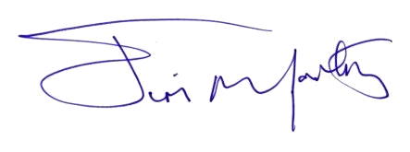
Reverend James McCartney
Executive Director
THOMAS

18 December 2025

St Anne’s House, France Street, Blackburn Lancashire BB2 1LX

